**Writing Python code on the Linux machine running on the FOSS Cloud Server :-**

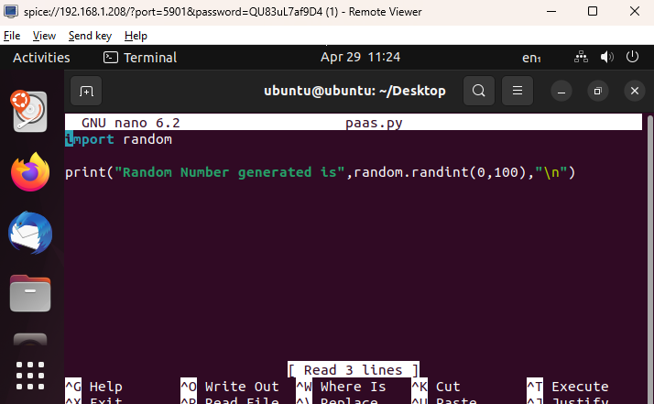

**Running the python program :-**

